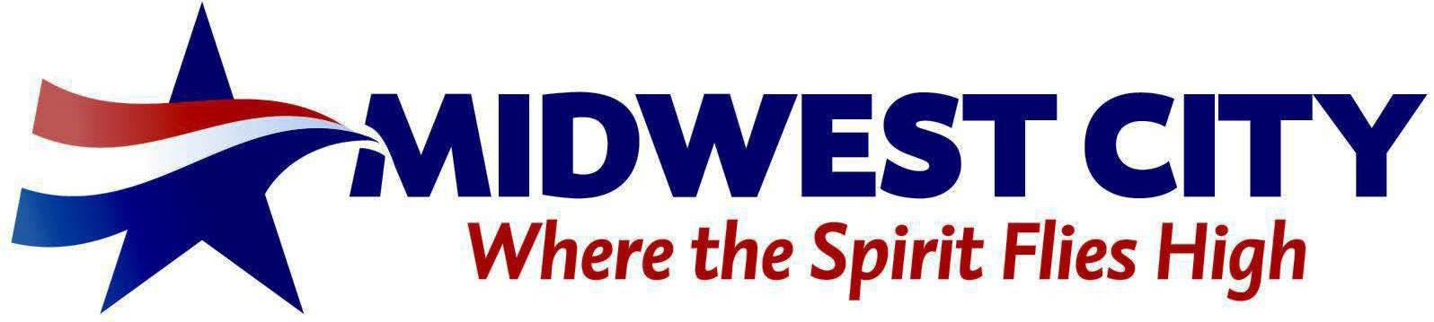

**ADDENDUM**

**TO THE CITY COUNCIL AGENDA**

City Hall – Midwest City Council Chambers, 100 N. Midwest Boulevard

January 25, 2022 – 6:00 PM

D. DISCUSSION ITEMS.

9. (PC-2099) Public hearing with discussion and consideration for adoption, including any possible amendment of an ordinance to redistrict from C-3, Community Commercial and R-6, Single Family Residential to PUD, Planned Unit Development, governed by the R-MD, Medium Density Residential and a resolution to amend the Comprehensive Plan from LDR, Low Density Residential, and OR, Office Retail, to MDR, Medium Density Residential, for the property described as a part of the SW/4 of Section 34, T-12-N, R-2-W, located at 2905 and 2913 N. Glenhaven Drive and 198 and 208 Marlow Drive. (Community Development - B. Harless)

10. Discussion and consideration for adoption, including any possible amendment of, the American Recovery Plan Act list of projects and projected costs of $9,858,239 (T. Lyon - CM Office).