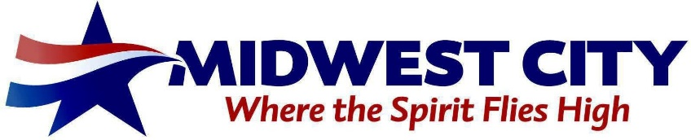

AGENDA FOR THE CITY OF MIDWEST CITY

LOCAL DEVELOPMENT ACT REVIEW COMMITTEE

Titan Room, Harroz Community Center,
200 N. Midwest Boulevard,
Midwest City, OK 73110

July 19, 2023 – 3:00 PM

A. CALL TO ORDER.
B. DISCUSSION ITEMS.
1. Discussion and consideration, including any amendment, of approving the minutes of the May 19, 2022 special meeting.
2. Presentation, Discussion and Consideration, Including Any Possible Amendment, on the First Amendment to the Project Plan Relating to Increment District Number Three, City of Midwest City, Oklahoma (North Side Improvement Increment District).
3. Discussion and Possible Action Regarding A Resolution Adopting Recommendations and Findings, Including Any Possible Amendment, in Regard to the Amending of Increment District Number Three, City of Midwest City, Oklahoma (North Side Increment District) and Its Related Project Plan; and Containing Other Provisions Relating Thereto.
C. ADJOURNMENT.

