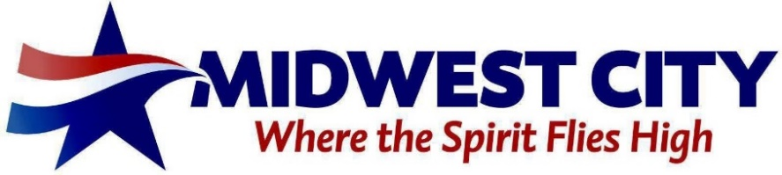

SPECIAL MEMORIAL HOSPITAL AUTHORITY,

BOARD OF GRANTORS AGENDA

City Hall - Midwest City Council Chambers, 100 N. Midwest Boulevard

June 27, 2024 – 5:30 PM

Presiding member: Ward 2 Rep. Zack Watts City Staff:
Ward 1 Rep. Chris Cooney Ward 5 Vacant General Manager Tim Lyon
Ward 3 Rep. Vacant Ward 6 Rep. Wade Moore Secretary Sara Hancock
Ward 4 Rep. Kelly Albright Mayor Rep. Amber Moody Authority Attorney Don Maisch
Chamber Rep. Bill Croak Chamber Rep. Stacy Willard
A. CALL TO ORDER.
B. DISCUSSION ITEMS.
1. Discussion, consideration and possible action of electing a Chairman, Vice-Chairman, and Secretary/Treasurer from the Board of Grantors to serve for a one-year term. (City Manager - T. Lyon)
2. Discussion, consideration and possible action to approve the minutes of the January 18, 2024 special meeting. (Secretary - S. Hancock)
3. Discussion, consideration, and possible action of approving the Midwest City Memorial Hospital Authority Community Improvement Grant Program documents for fiscal year 2024-2025.
4. Discussion, consideration, and possible action of approving the Year-End Report of the Memorial Hospital Authority Trust Board of Grantors for Fiscal Year 2023-2024.
C. ADJOURNMENT.

