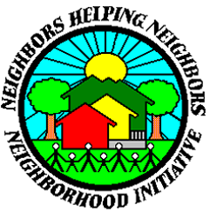Magnolia Ridge HOA

**CITY REPRESENTATIVE INFORMATION**

**Barbara Kelton | Coordinator**

[bkelton@midwestcityok.org](mailto:bkelton@midwestcityok.org)

405-739-1010

**SGT Lindsay Cargal | Community Action Officer** [lcargal@midwestcityok.org](mailto:lcargal@midwestcityok.org)

405-739-1024

**Megan Bain | City Council Ward 3 |** [ward3@midwestcityok.org](mailto:ward3@midwestcityok.org)

**Brian Wood | Code Officer**

[bwood@midwestcityok.org](mailto:bwood@midwestcityok.org)

405-739-1002

Neighborhood Association Information

## Meeting Schedule

## When: Annually in January

## (No meetings in June or October due to city-wide neighborhood events)

## Time: 6:30 PM

## Where: Charles J Johnson Building

## (8726 SE 15th St, MWC, OK 73110)

Association Contact information

## President: Raymond Bussell | [rbussell1@cox.net](mailto:rbussell1@cox.net)

**VP:** Wayne Palyola | [waypay@cox.net](mailto:waypay@cox.net)

**Treasurer:** Cindy Jones | [cjones1129@outlook.com](mailto:cjones1129@outlook.com)

**Boundaries:**

**12 homes off Magnolia Ridge, south side of Reno, just east of Post Rd.**